Agent Development Frameworks

LangChain
High-level Architecture:
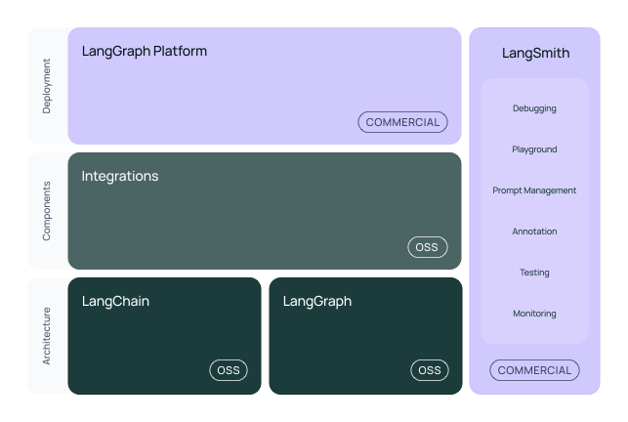Source: LangChain Documentation
Key Features:
- LangChain became a de facto standard for building AI Apps with 1M+ builders with ~100K GitHub Stars.
- Comprehensive vendor integration, cloud-vendor support, third-party libraries integration, diverse vector databases, and many more.
- Wider community knowledge and developer awareness make it the most commonly used framework.
Suitable for (Pros):
- Most applicable for enterprise development with wider adoption as a standard and community-driven support.
- Building the foundational building blocks of the enterprise applications for GenAI—LangChain is best suited for creating enterprise-specific frameworks.
- It is best suitable where compatibility with third-party vendors is required with a forward-looking view of integration with different solutions or products considering the wider adoption of the LangChain framework.
- LangChain has inspired developer community to built similar frameworks in other languages such as LangChain4J for Java, LangChainGo for Golang, and LangChain for C#.
Where other frameworks flare better (Cons):
- Complexity and increased learning cycle with too many integrations and code complexity. For simplicity and specific purposes, other frameworks can be considered as per the context.
- Continuous features/changes require developers to keep the code updated along with the possibility of breaking changes, incompatible libraries, etc.

LangGraph
High-level Architecture:
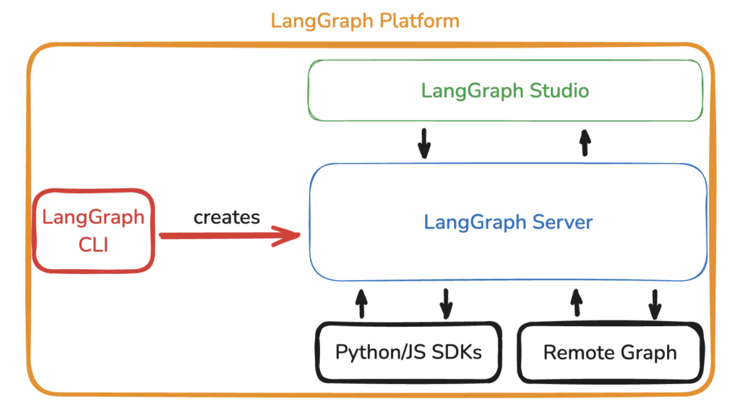
Source: LangGraph Platform Architecture
Key Features:
- LangGraph framework is an open-source framework provided by the LangChain team supporting agentic architecture. LangGraph Platform is a commercial solution for deploying agentic applications to production.
- Stateful design, graph-based workflow, multi-agent capabilities, native integration with LangChain, enhanced observability with LangSmith, IDE support, and wider community support are key features of the platform.
Suitable for (Pros):
- Most applicable for enterprise multi-agent framework development with wider adoption as a standard and community-driven support.
- A wide variety of compatibility is required with a forward-looking view of integration with different solutions or products.
- Best suitable within the ecosystem of LangChain combination avoiding many frameworks in the enterprise.
Where other frameworks flare better (Cons):
- Enterprise-required features such as security, visual development, enhanced observability, etc. are supported in the commercial version.
- Like LangChain, the developers have identified handling dependencies and the framework’s complexity as major obstacles.

Google ADK
Agent Development Kit (ADK) is a flexible and modular framework for developing and deploying AI agents. While optimized for Gemini and the Google ecosystem, ADK is model-agnostic, deployment-agnostic, and is built for compatibility with other frameworks. ADK was designed to make agent development feel more like software development, to make it easier for developers to create, deploy, and orchestrate agentic architectures that range from simple tasks to complex workflows.
High-level Architecture:

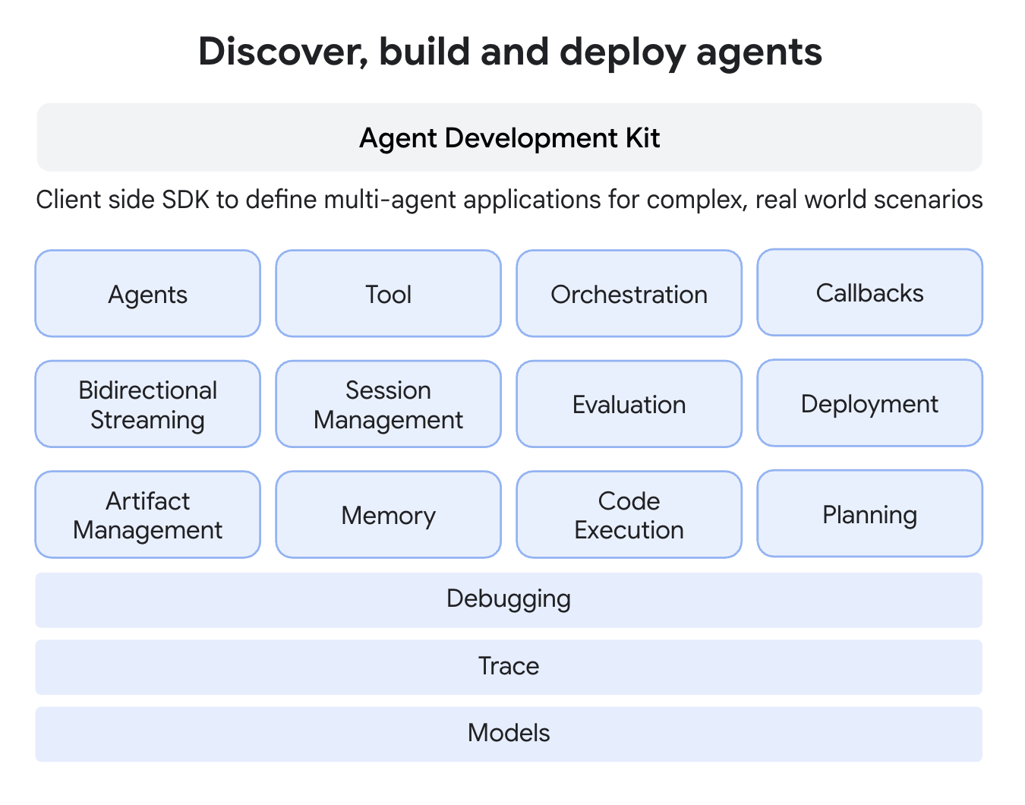
Source: https://google.github.io/adk-docs/get-started/about/
Key Features:
- Native framework for building and orchestrating agentic workflows on Google Cloud
- Tight integration with Vertex AI and Gemini models
- Built-in support for multi-agent coordination and task decomposition
- First-class tool invocation and function calling
- Enterprise-grade security, policy enforcement, and IAM integration
- Observability hooks aligned with Google Cloud logging and monitoring
- Managed deployment and scaling using GCP infrastructure
Suitable for (Pros):
- When you are looking for a framework across multiple languages as ADK supports Golang, Java, Python, TypeScript
- Organizations standardized on Google Cloud and Vertex AI
- Enterprise use cases requiring governed and secure agent deployments
- Large-scale, production-grade multi-agent systems
- Regulated industries needing strong compliance and auditability
- Teams prioritizing managed services over custom infrastructure
- Scenarios benefiting from tight coupling with Gemini model capabilities
Where other frameworks flare better (Cons):
- Limited flexibility for multi-cloud or on-prem deployments
- Strong dependency on Google Cloud services and ecosystem
- Less suitable for rapid experimentation or research-heavy workflows
- Reduced control over low-level agent state compared to graph-based rameworks
- Smaller open-source ecosystem compared to LangGraph, CrewAI, or AutoGen
- Slower iteration for teams seeking lightweight, model-agnostic frameworks

AWS Strands Agents
High-level Architecture:
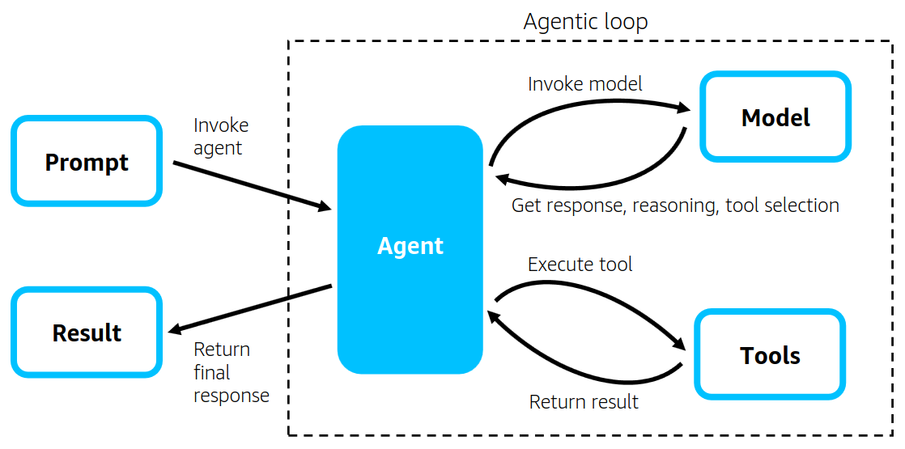
Reference: https://strandsagents.com/
Blog: https://aws.amazon.com/blogs/opensource/introducing-strands-agents-an-open-source-ai-agents-sdk/
Key Features:
- Model-driven, autonomous agent loop that leverages a foundation model for planning, reasoning, tool selection, and execution. AWS Documentation
- Lightweight, code-first SDK with simple Python/TypeScript APIs for agent creation and execution. Strands Agents
- Model and provider agnostic — supports Amazon Bedrock, OpenAI, Anthropic, Llama, and other providers via flexible interfaces. Amazon Web Services, Inc.
- Native AWS ecosystem integration (e.g., AWS Lambda, Step Functions, EC2/EKS) for seamless workflows and deployment. AWS Documentation
- Tooling support via Model Context Protocol (MCP) enabling standardized connection to external tools and resources. AWS Documentation
- Multi-agent coordination primitives including agents-as-tools, swarms, graphs, and meta-agents for complex workflows. Amazon Web Services, Inc.
- Production-ready observability with OpenTelemetry support for tracing, logging, and metrics. Amazon Web Services, Inc.
- Flexible deployment targets from local development to cloud production environments. Strands Agents
Suitable for (Pros):
- Ideal for AWS-centric development teams seeking deep integration with cloud services and infrastructure. AWS Documentation
- Excellent choice for enterprise use cases requiring security, compliance, and controlled deployment patterns. AWS Documentation
- Strong option for autonomous agent workflows that need flexible model selection across providers. AWS Documentation
- Simplifies production readiness with observability and telemetry built into the SDK. Amazon Web Services, Inc.
- Supports multi-modal interactions and collaboration between agents for complex problem solving. AWS Documentation
- Offers scalable deployment paths (Lambda, Fargate, EC2/EKS, containerized environments). Strands Agents
Where other frameworks flare better (Cons):
- AWS ecosystem focus can feel restrictive if you want a truly cloud-agnostic or hybrid environment; other frameworks like LangGraph or AutoGen may be more neutral. AWS Documentation
- Model-first autonomous loop may introduce non-determinism that complicates debugging and reproducibility compared to frameworks with explicit orchestration logic. Medium
- Newer ecosystem with a smaller community and tooling ecosystem compared to mature open frameworks like LangChain or CrewAI. Medium
- Potential for higher development costs and complexity early on due to model-driven reasoning and reliance on LLM loops. SelectHub
- Some teams might prefer frameworks with more explicit workflow orchestration or specialized tools like LangGraph’s graph execution patterns

Microsoft Agent Framework
Microsoft Agent Framework is an open-source development kit for building AI agents and multi-agent workflows for .NET and Python. It brings together and extends ideas from Semantic Kernel and AutoGen projects, combining their strengths while adding new capabilities. Built by the same teams, it is the unified foundation for building AI agents going forward.
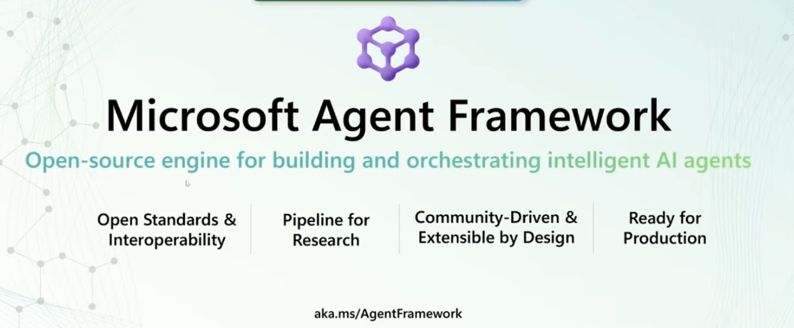
Source: https://aka.ms/AgentFrameWork
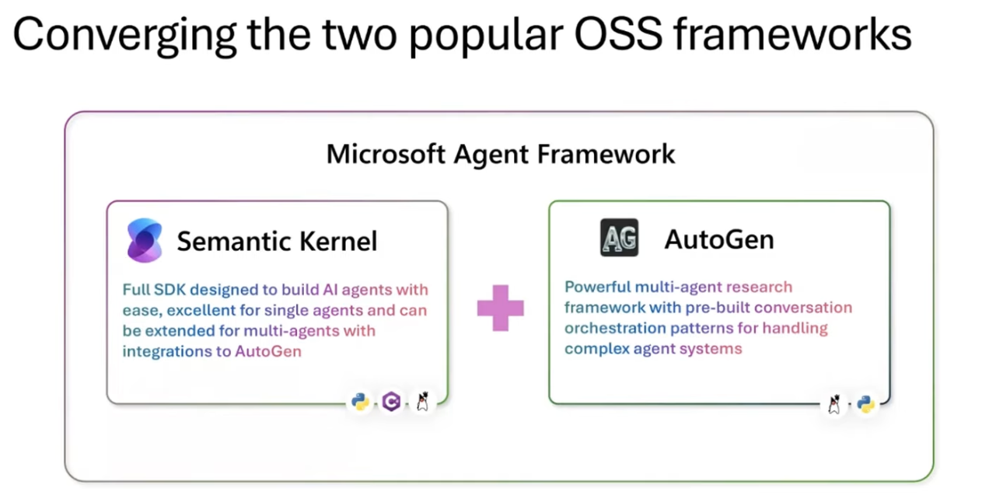
Source: https://www.youtube.com/watch?v=JlzteydCK_Q
High-level Architecture:
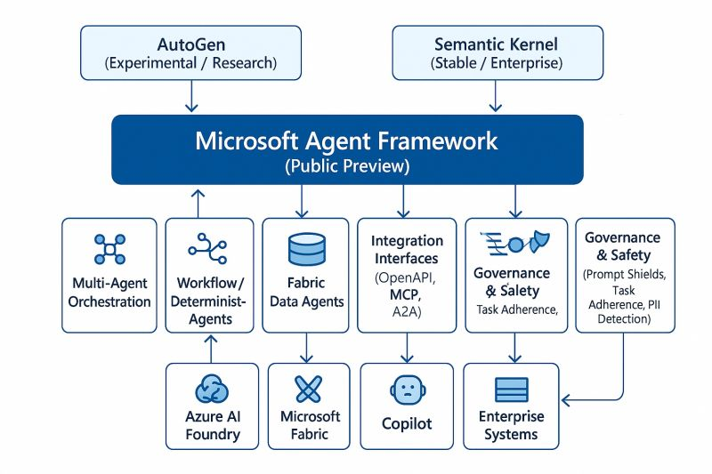
Doc: https://learn.microsoft.com/en-us/agent-framework/
Key Features:
- Unified open-source framework for building, orchestrating, and deploying AI agents and multi-agent workflows in .NET and Python environments. Microsoft Learn
- Combines strengths of Semantic Kernel and AutoGen, offering enterprise grade features (thread-based state management, type safety, telemetry, model/embedding support) with intuitive multi-agent patterns. Microsoft Learn
- AI agents that process user inputs with LLMs, call tools and MCP servers, and generate responses; supports providers such as Azure OpenAI and OpenAI. Microsoft Learn
- Graph-based workflow orchestration enabling complex, multi-step processes with nesting, conditional routing, parallel execution, and human-in-the-loop integration. Microsoft Learn
- Foundational building blocks such as model clients, context providers (memory), middleware, and agent threads for state and action management. Microsoft Learn
- Strong developer infrastructure with tooling, samples, migration guides (from AutoGen / Semantic Kernel), and community contributions. GitHub
- Preview status with open feedback and GitHub ecosystem participation for ongoing improvements. Microsoft Learn
Suitable for (Pros):
- Teams building enterprise-grade AI agent systems that need robust state management, telemetry, and type safety. Microsoft Learn
- Organizations standardizing on .NET or Python stacks with seamless integration into Azure and Microsoft developer tooling. GitHub
- Projects requiring explicit workflow orchestration with clear execution control and coordinator components. Microsoft Learn
- Use cases where modularity, reuse, and composability matter—thanks to graph-based workflows, strong typing, and nested execution. Microsoft Learn
- Scenarios involving long-running processes or human-in-the-loop interactions, supported by checkpoints and flexible flow management. Microsoft Learn
- Developers who want a single unified framework instead of piecing together multiple agent libraries. Microsoft Learn
Where other frameworks flare better (Cons):
- Less cloud-agnostic: Tighter coupling with Microsoft ecosystems may be suboptimal compared to more neutral or multi-cloud frameworks (e.g., LangGraph, CrewAI) for heterogeneous deployments. GitHub
- Still in preview: Production-critical applications may prefer more mature frameworks with wider community adoption and stability. Microsoft Learn
- Complexity for simple tasks: High-level orchestration and strong typing may be overkill for lightweight or quick proof-of-concept agents compared to simpler SDKs. Microsoft Learn
- Smaller ecosystem: Emerging community and tooling base relative to long-standing open frameworks like LangChain or standalone agent SDKs with larger contributor networks. GitHub
- Azure influence: While supporting multiple providers, developers seeking full control over model and runtime choices outside Azure/Azure AI may find constraints or extra integration work. Microsoft Learn

Autogen
High-level Architecture:
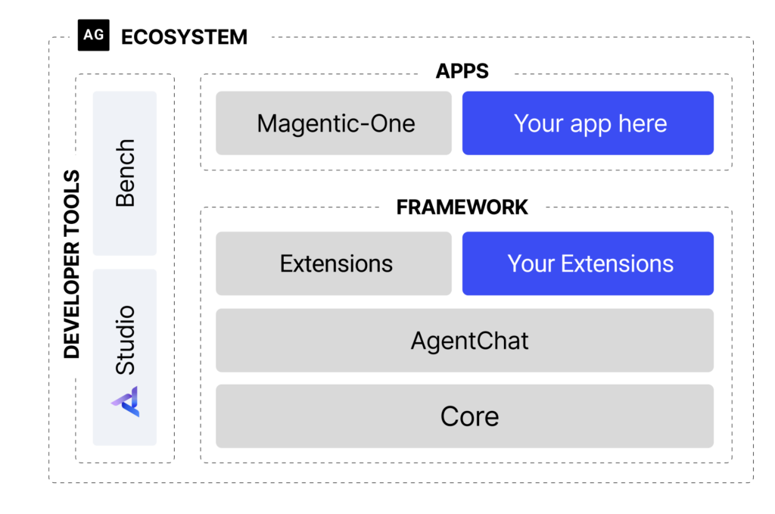Source: Autogen (0.4)
Key Features:
- Autogen is a programming framework, developed by Microsoft, for building Agentic AI agents and applications. It provides a multi-agent conversation framework as a high-level abstraction.
- Asynchronous messaging, modular and extensible, observability and debugging, scalable and distributed, built-in and community extensions, cross-language support, and full-type support are key features of the Autogen framework.
- AutoGen supports enhanced LLM inference APIs, which can be used to improve inference performance and reduce cost.
Suitable for (Pros):
Software
- When alignment with open-source and Microsoft ecosystems is prevalent, Autogen is a suitable solution for building agentic applications and AI agents.
- AutoGen offers an evolving ecosystem to support a wide range of applications from various domains and complexities. It also has an Autogen studio UI application for prototyping and managing agents without writing code.
Where other frameworks flare better (Cons):
- Autogen continues to be experimental (not completely production-ready) and not production-ready. If you are researching complex agent interactions, prototyping new multi-agent systems, or want to experiment with advanced AI agent designs.
- While Autogen is an open-source solution, dependency on Microsoft solutions can be a consideration based on the organizational context. Magentic-One is a commercial solution, built on top of Autogen, offering advanced capabilities such as a high-performing generalist agentic system for enterprises.
- The complexity of setting up Autogen, particularly within an enterprise has been observed as a key concern.

Semantic Kernel
High-level Architecture:
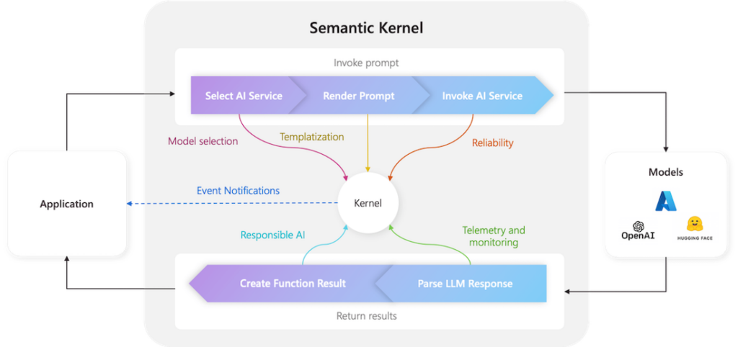Source: Semantic Kernel Docs
Key Features:
- Semantic Kernel (by Microsoft) is designed for creating stable, enterprise-ready applications with strong integration capabilities.
- As per Microsoft – Semantic Kernel is a production-ready SDK that integrates large language models (LLMs) and data stores into applications, enabling the creation of product-scale GenAI solutions. Semantic Kernel supports multiple programming languages: C#, Python, and Java. Semantic Kernel has an Agent and Process Frameworks in preview, enabling customers to build single-agent and multi-agent solutions.
- It has inbuilt core frameworks as Agent Framework and Process Framework. The Semantic Kernel Agent Framework provides a platform within the Semantic Kernel ecosystem that allows for the creation of AI agents and the ability to incorporate agentic patterns into any application. The Semantic Kernel Process Framework provides an approach to optimize AI integration with your business processes.
Suitable for (Pros):
Mobile Apps & Add-Ons
- If you need to build a reliable AI agent for a production environment with strong enterprise-level support and integration with existing systems.
- When SDKs are needed in multiple languages as Semantic Kernel supports Python, C#, .Net, and Java.
- Developer training support with enterprise support is available, particularly in the Microsoft Azure environment. Check out the course on using Semantic Kernel with Azure by clicking here.
Where other frameworks flare better (Cons):
- Semantic Kernel falls into the category of SDK whereas the competitive frameworks provide higher-level abstractions and user interfaces for simpler agents.
- Agent framework is still evolving (Agents are currently not available for Java).
- When vendor dependency on Microsoft needs to be avoided, other options can be considered as per the context.

LlamaIndex
High-level Architecture:
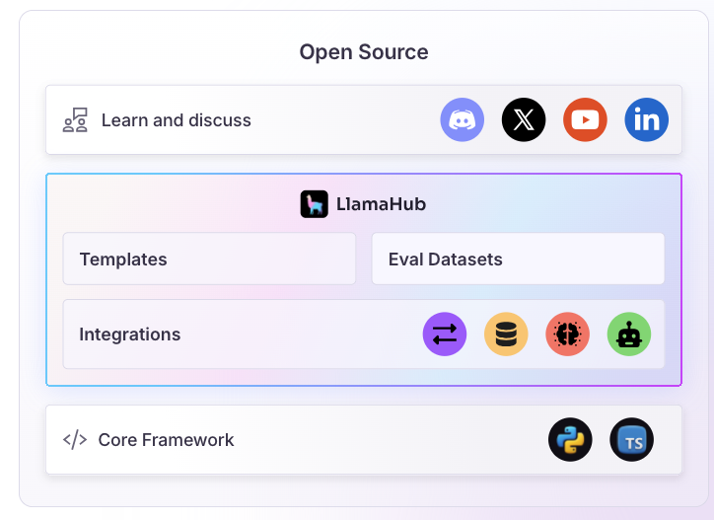Source: LlamaIndex Framework
Key Features:
- LlamaIndex started with data framework capabilities for LLM applications and has evolved to cover AI agents, document parsing & indexing, workflow, connectors-based integration, modularity & extensibility, and many more capabilities.
- It offers a SaaS capability as LlamaCloud as a knowledge management hub for AI Agents. LlamaParse is a differentiated offering for transforming instructed data into LLM-optimized formats.
- LlamaHub is a great initiative as a centralized place to explore Agents, LLMs, Vector Stores, Data Loaders, etc.
Suitable for (Pros):
Development Tools
- As an alternative to LangChain, LlamaIndex has evolved as a compelling alternative, particularly for data-intensive LLM applications.
- The ability to parse and index complex documents efficiently with LlamaCloud makes it a compelling option for enterprises seeking quicker time-to-market.
- Building knowledge-intensive AI systems like chatbots and question-answering systems.
Where other frameworks flare better (Cons):
- Primarily focused on data indexing and retrieval, with less emphasis on complex agent behaviors and decision-making. However, the evolution of the framework towards building Agentic apps provides promising capabilities.

AutoGPT
High-level Architecture:
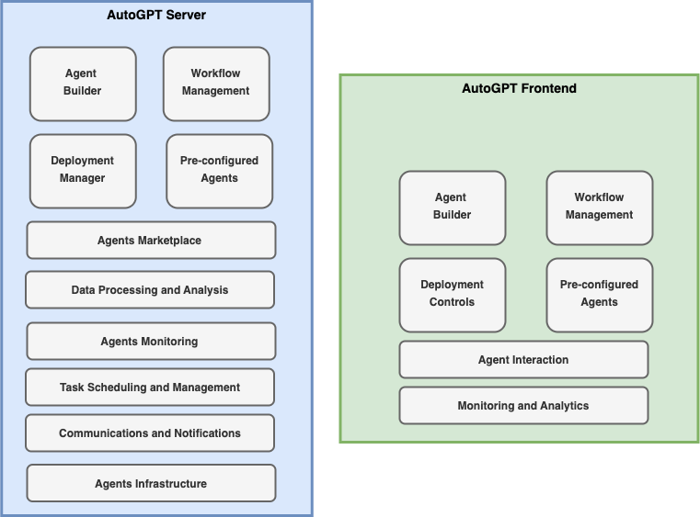AutoGPT Platform Components
Key Features:
- AutoGPT, built by Significant Gravitas, is a powerful platform that allows you to create, deploy, and manage continuous AI agents that automate complex workflows. It was originally built on top of OpenAI’s GPT but extended to support additional LLMs (Anthropic, Groq, Llama).
- Key features: Seamless Integration and Low-Code Workflows, Autonomous Operation and Continuous Agents, Intelligent Automation and Maximum Efficiency, Reliable Performance and Predictable Execution
Suitable for (Pros):
Educational Resources
- No code or low-code-centric approach for building agents is preferred with the ability to build the agents in the Cloud (while it offers a self-hosted solution, the setup complexity is higher).
Where other frameworks flare better (Cons):
- Vendor dependency and lock-in to access advanced features can be key concerns for enterprises. The cloud-hosted solution is in the roadmap and currently being offered to waitlist consumers.
- The complexity of licensing support – currently it has dual licensing support while the majority is being offered as an MIT license.
- Additional LLM support such as Google’s Gemini and more will continue to be be a key challenge along with community support.

CrewAI
High-level Architecture:
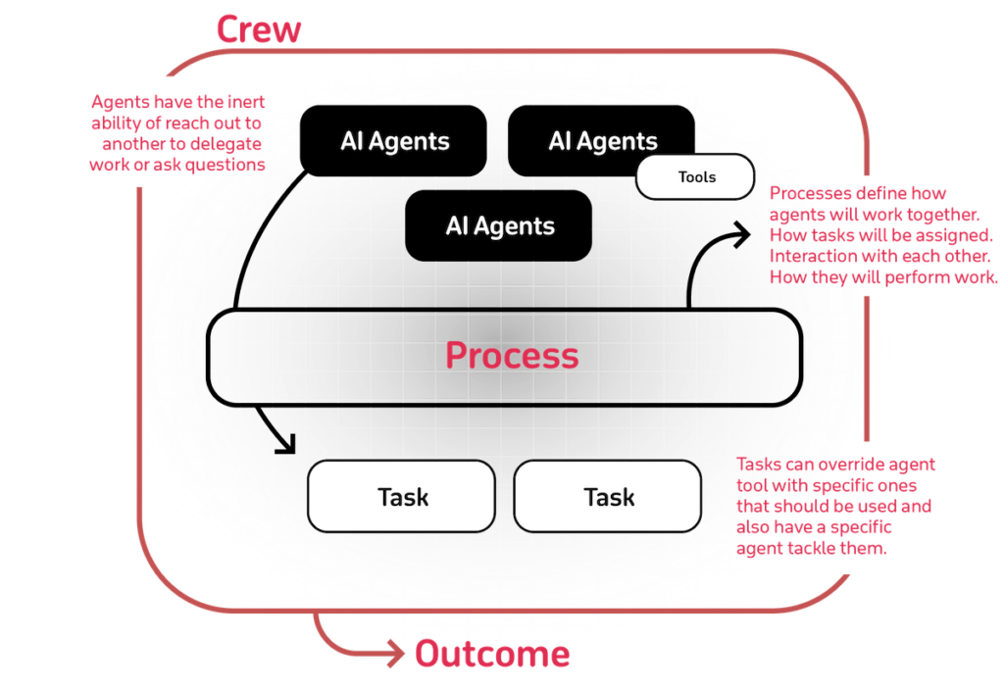Source: CrewAI Documentation
Key Features:
- CrewAI emerged as a promising multi-agent framework to build and deploy workflow-based applications with support from a wide array of LLMs and Cloud providers.
- Multi-agent collaboration, structured workflow design, user-friendly interface, integration flexibility, and community support are salient features of CrewAI.
Suitable for (Pros):
Software
- CrewAI has emerged as the fastest growing AI agents ecosystem and raised funding of $18M in Oct 2024. The simplicity of creating business-friendly agents has made it easy to understand realizing the value of GenAI quickly.
- Quicker time-to-market with out-of-the-box customization and more suitable for building lightweight agents such as marketing agents.
Where other frameworks flare better (Cons):
- The ability to handle large enterprise-specific complex scenarios with data integration has not been production-tested and will need to be assessed in the future.
- The vendor dependency and lock-in have been a key consideration and the possibility of CrewAI to be acquired by one of the hyperscalers or other players remains an open question.

PydanticAI
High-level Architecture:
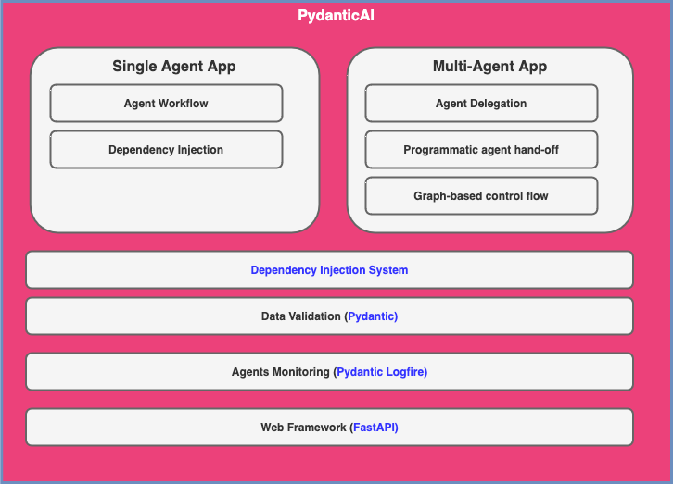PydanticAI Components
Key Features:
- PydanticAI: Built by the Pydantic team to bring that FastAPI feeling to GenAI app development. Integration with Pydantic Logfire for GenAI application’s observability along with the support for multiple LLMs and ecosystem support.
- The salient features are the Pydantic approach, model agnostic implementation, real-time observability, type-safety, graph-support with Pydantic Graph, dependency injection, and simplicity.
Suitable for (Pros):
Machine Learning & Artificial Intelligence
- Applications leveraging Pydantic and FastAPI approach and looking for simple framework aligned with associated enterprise technology stack.
- It is suitable for simple scenarios as the framework is still evolving.
Where other frameworks flare better (Cons):
- This framework is still in the early stages (beta) and is expected to introduce many changes as it progresses.

Spring AI
High-level Architecture:
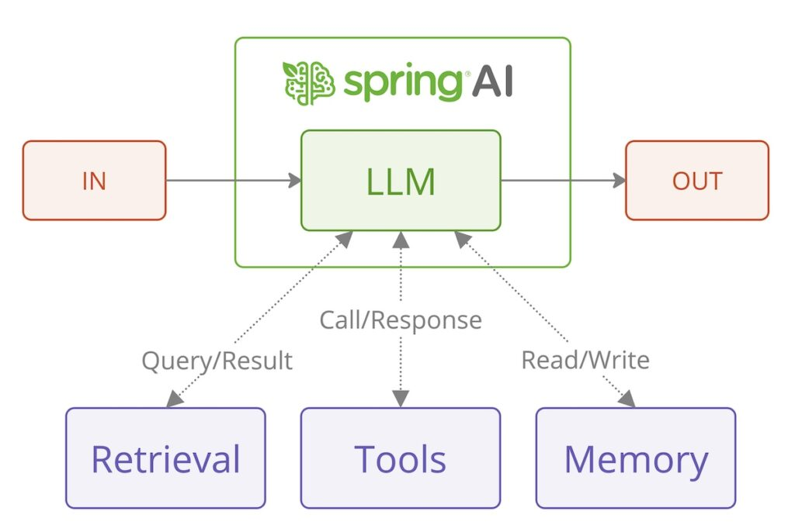Source: Spring AI for Building Agentic Systems
Key Features:
- Spring AI is inspired by LangChain, Spring AI leverages Spring ecosystems to build GenAI applications in Java ecosystem.
- Key features include support for multiple LLMs, observability features in the Spring ecosystem, model evaluation, Advisors API for encapsulating recurring Generative AI patterns, chat conversations, and RAG.
Suitable for (Pros):
Development Tools
- With enterprise GenAI applications leveraging the Spring ecosystem, it alleviates the need for learning additional frameworks or languages.
- It provides seamless integration with the broader Spring ecosystem to leverage the libraries available for data connectivity, asynchronous processing, system integration, and more.
Where other frameworks flare better (Cons):
- Spring AI is relatively novel and still in the early stages – it needs to be compared with features required in a complex business scenario to consider alternative frameworks.

Haystack
High-level Architecture:
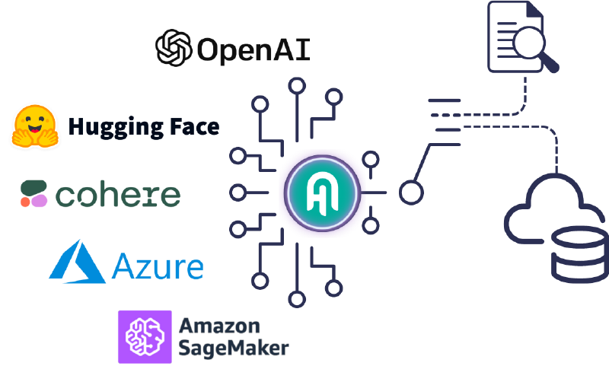Source: Haystack
Key Features:
- Haystack (built by deepset) is an open-source framework or building production-ready LLM applications, RAG pipelines, and complex search applications for enterprises.
- It has been built applying modular architecture principles combining technology from OpenAI, Chroma, Marqo, and other open-source projects, like Hugging Face’s Transformers or Elasticsearch.
Suitable for (Pros):
Mobile Apps & Add-Ons
- It is suitable for building LLM applications for any Cloud with deepsetCloud as an LLM AI platform, which provides in-built LLMOps capabilities.
- A custom RAG pipeline with Jinja templates for components.
- deepset Studio is a free AI application development environment for Haystack, which augments the development lifecycle.
Where other frameworks flare better (Cons):
- Multi-agent capabilities are yet to be battle-tested and the roadmap needs to be reflected to understand the bigger picture.

Other Frameworks
- OpenAI Swarm: An educational framework (not production-ready) exploring ergonomic, lightweight multi-agent orchestration.
- MetaGPT: A multi-agent framework of AI agents, built by researchers (research paper), promotes the idea of meta-programming.
- Flowise: An open-source framework providing drag-and-drop UI to build agents with customized LLM flows.
- Langflow: An open-source framework (acquired by DataStax) to build flow-based GenAI apps interactively.
- OpenAGI: A simple framework, built by AI Planet, for building human-like agents.
- Camel-AI.org: An open-source multi-agent framework to build customizable agents, inspired by a research paper CAMEL (Communicative Agents for “Mind” Exploration of Large Language Model Society).
- DAPR Agents:
- PraisonAI: a production-ready Multi AI Agents framework, designed to create AI Agents to automate and solve problems ranging from simple tasks to complex tasks.
- BroadAI: A Multi-Agent Framework for building powerful & intelligent AI Systems
- Vellum: A platform with products for Orchestration, Evaluation, Prompting, Retrieval, and Deployment - as a GUI tool for building and testing complex workflows.
- Rivet: a drag and drop GUI LLM workflow builder
- Solace Agent Mesh
- Akka Agent Platform

